Task 3
Submitted by:
Sarvesh Nabar

Internship: InternSpark Internship
Technology: HTML, CSS, JavaScript

login page
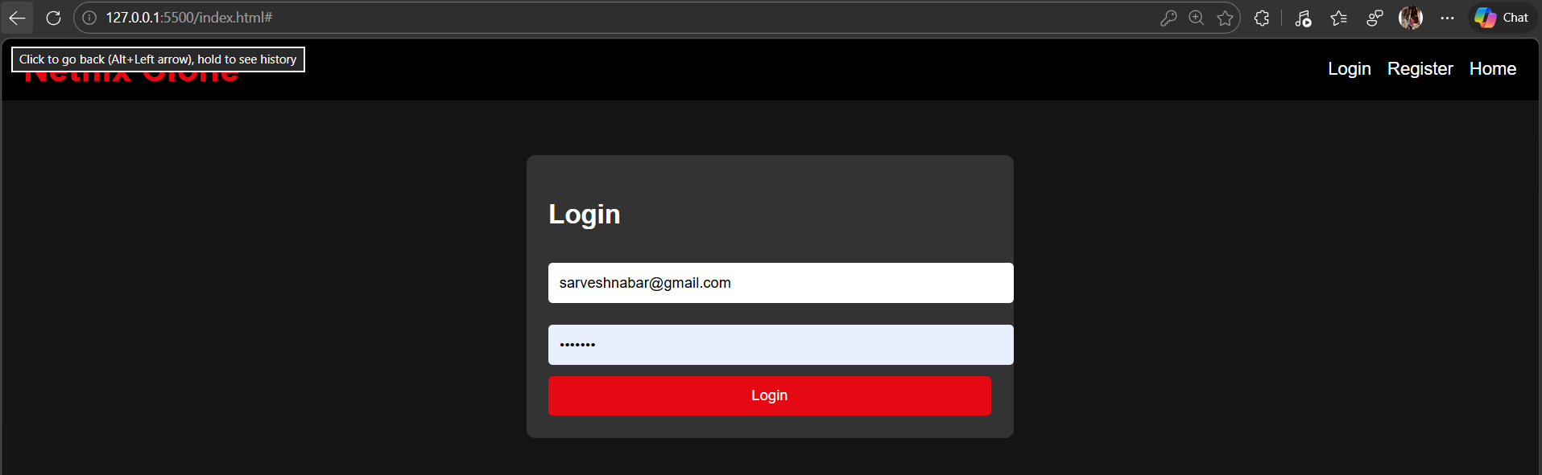

Register page
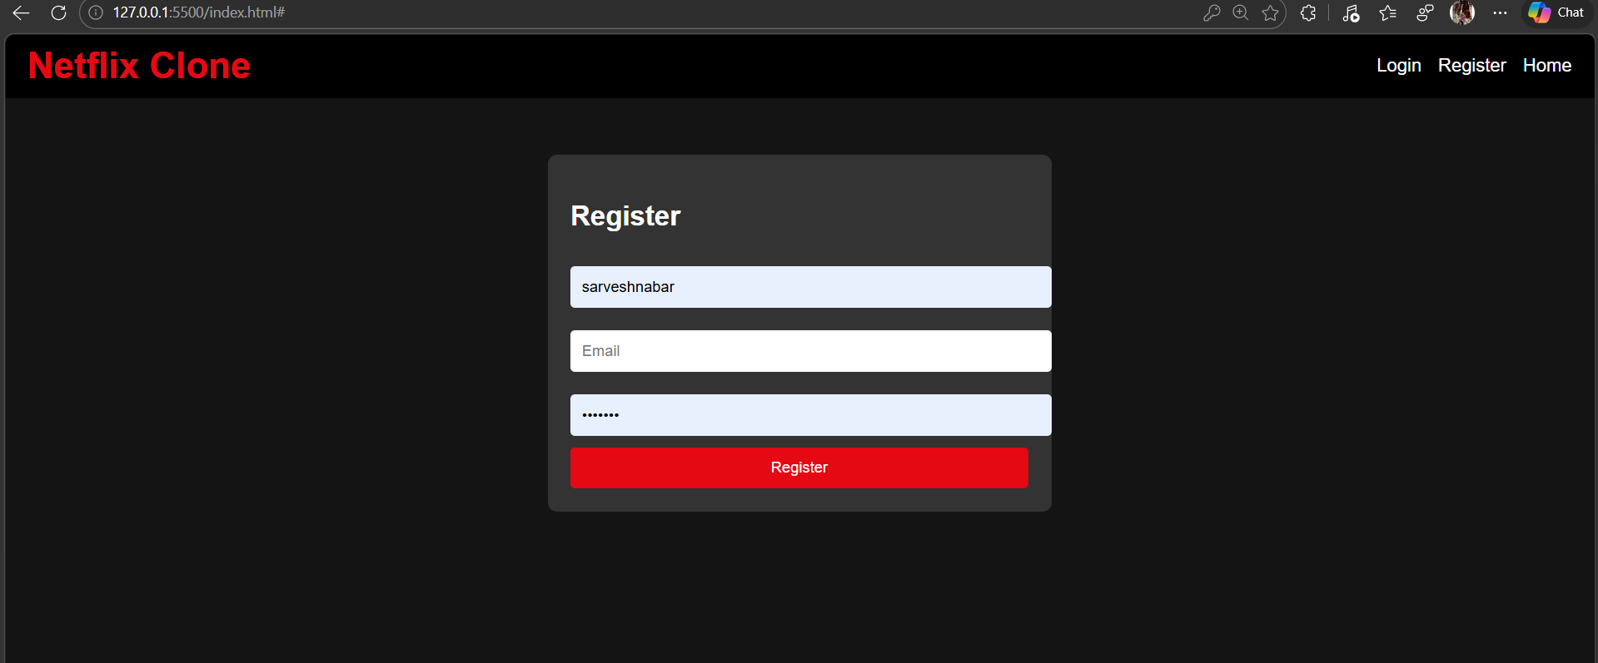

Home page
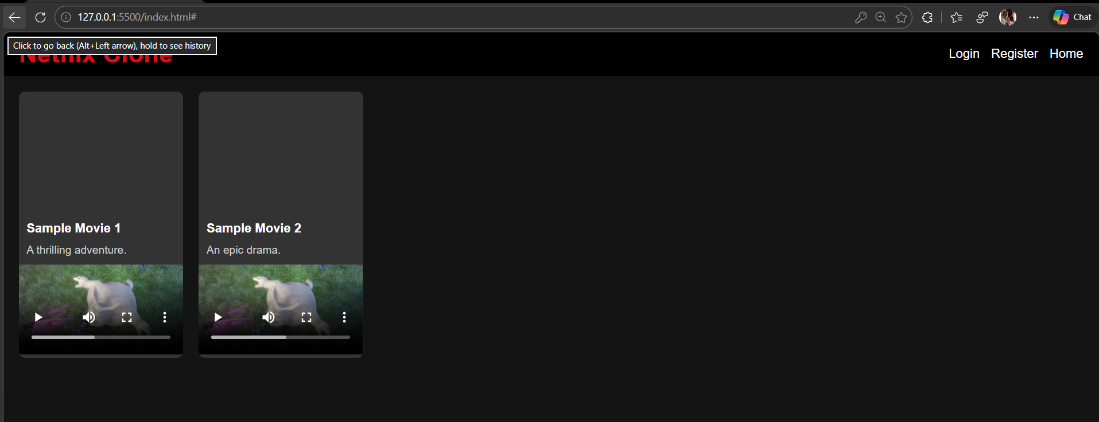

Code
<!DOCTYPE html>
<html lang="en">
<head>
<meta charset="UTF-8">
<meta name="viewport" content="width=device-width, initial-scale=1.0">
<title>Netflix Clone</title>
<style>
body {
margin: 0;
font-family: 'Helvetica Neue', Helvetica, Arial, sans-serif;
background-color: #141414;
color: white;
}
.navbar {
background-color: #000;
padding: 10px 20px;
display: flex;
justify-content: space-between;
align-items: center;
}
.navbar h1 {
color: #e50914;
margin: 0;
}
.navbar a {
color: white;
text-decoration: none;
margin-left: 10px;
}
.page {
display: none;
}
.active {
display: block;
}
.movie-grid {
display: grid;
grid-template-columns: repeat(auto-fill, minmax(200px, 1fr));
gap: 20px;
padding: 20px;
}
.movie-card {
background-color: #333;
border-radius: 8px;
overflow: hidden;
transition: transform 0.3s;
}
.movie-card:hover {
transform: scale(1.05);
}
.movie-card img {
width: 100%;
height: 150px;
object-fit: cover;
}
.movie-card h3 {
margin: 10px;
font-size: 16px;
}
.movie-card p {
margin: 10px;
font-size: 14px;
color: #ccc;
}
.form {
max-width: 400px;
margin: 50px auto;
padding: 20px;
background-color: #333;
border-radius: 8px;
}
.form input {
width: 100%;
padding: 10px;
margin: 10px 0;
border: none;
border-radius: 4px;
}
.form button {
width: 100%;
padding: 10px;
background-color: #e50914;
color: white;
border: none;
border-radius: 4px;
cursor: pointer;
}
.form button:hover {
background-color: #f40612;
}
</style>
</head>
<body>
<nav class="navbar">
<h1>Netflix Clone</h1>
<div>
<a href="#" onclick="showPage('login')">Login</a>
<a href="#" onclick="showPage('register')">Register</a>
<a href="#" onclick="showPage('home')">Home</a>
</div>
</nav>

<div id="login" class="page active">
<form class="form" onsubmit="handleLogin(event)">
<h2>Login</h2>
<input type="email" id="loginEmail" placeholder="Email" required>
<input type="password" id="loginPassword" placeholder="Password" required>
<button type="submit">Login</button>
</form>
</div>

<div id="register" class="page">
<form class="form" onsubmit="handleRegister(event)">
<h2>Register</h2>
<input type="text" id="regUsername" placeholder="Username" required>
<input type="email" id="regEmail" placeholder="Email" required>
<input type="password" id="regPassword" placeholder="Password" required>
<button type="submit">Register</button>
</form>
</div>

<div id="home" class="page">
<div class="movie-grid" id="movieGrid">
<!-- Movies will be populated here -->
</div>
</div>

<script>
// Mock data for movies (since no backend)
const mockMovies = [
{
id: 1,
title: 'Sample Movie 1',
description: 'A thrilling adventure.',
thumbnail: 'https://via.placeholder.com/200x150',
videoUrl: 'https://www.w3schools.com/html/mov_bbb.mp4'
},
{
id: 2,
title: 'Sample Movie 2',
description: 'An epic drama.',
thumbnail: 'https://via.placeholder.com/200x150',
videoUrl: 'https://www.w3schools.com/html/mov_bbb.mp4'
},
// Add more as needed
];

// Function to show a page
function showPage(pageId) {
document.querySelectorAll('.page').forEach(page => page.classList.remove('active'));
document.getElementById(pageId).classList.add('active');
if (pageId === 'home') {
loadMovies();
}
}

// Handle login (simulate with localStorage)
function handleLogin(event) {
event.preventDefault();
const email = document.getElementById('loginEmail').value;
const password = document.getElementById('loginPassword').value;
// Simple check: assume any email/password is valid for demo
if (email && password) {
localStorage.setItem('user', JSON.stringify({ email }));
alert('Login successful!');
showPage('home');
} else {
alert('Invalid credentials');
}
}

// Handle register (simulate with localStorage)
function handleRegister(event) {
event.preventDefault();
const username = document.getElementById('regUsername').value;
const email = document.getElementById('regEmail').value;
const password = document.getElementById('regPassword').value;
if (username && email && password) {
localStorage.setItem('user', JSON.stringify({ username, email }));
alert('Registration successful! Please login.');
showPage('login');
} else {
alert('Please fill all fields');
}
}

// Load movies into the grid
function loadMovies() {
const grid = document.getElementById('movieGrid');
grid.innerHTML = '';
mockMovies.forEach(movie => {
const card = document.createElement('div');
card.className = 'movie-card';
card.innerHTML = `
<img src="${movie.thumbnail}" alt="${movie.title}">
<h3>${movie.title}</h3>
<p>${movie.description}</p>
<video controls width="100%">
<source src="${movie.videoUrl}" type="video/mp4">
Your browser does not support the video tag.
</video>
`;
grid.appendChild(card);
});
}

// Check if user is logged in on load
window.onload = function() {
const user = localStorage.getItem('user');
if (user) {
showPage('home');
} else {
showPage('login');
}
};
</script>
</body>
</html>

Github link
https://github.com/Sarveshnabar03/InternSpark-Internship/commit/0c33288ade82e5c53de19ee74ffce59b4bc7b592

